## Introduction

An Implicit Shape Model $ISM\left(C\right)=(I_{C}, P_{I,C})$ for a given object category $C$ consists of a class-specific codebook $I_{C}$ of local appearances that are prototypical for the object category, and a spatial probability distribution $P_{I,C}$ which specifies the probability of relative position with respect to the center of the object, for each codebook entry. After codebook entries are found in the target image, this spatial probability distribution will be used for a probabilistic Hough vote algorithm to identity the center location of the object.

In our scenario, we planned to use the *ISM* method for foreground/background segmentation. Here we only have two categories: foreground ${(C}_{1})$ and background $(C_{0})$. Moreover, we don’t care about the location of the object, thus the spatial probability distribution will be discarded. We will focus on generating the codebook $I_{C}$ of local appearance for both foreground and background and use it for segmentation.

## Approach

### Codebook of Local Appearance

Following the pipeline of *ISM* method, in order to generate a codebook of local appearances of particular object category, we follow the approaches used by [1]. From a variety input of color and depth images, patches of size $W_{c}×W_{c}$ (color) and $W_{d}×W_{d}$ (depth) were extracted around interest points for each object category. The interest points for each object category were identified using Harris corner detector [2]. For each pixel $(x,y)$ in a given grayscale image, Harris corner detector can give a response $R\left(x,y\right)$ to indicate the likelihood of that pixel being a corner or not. When $\left|R\left(x,y\right)\right|$ is small, the region surrounding $\left(x,y\right)$ is flat. When $|R\left(x,y\right)|$ is large, the region around the interest pixel is a corner. So the result of the Harris corner detector is a grayscale image with the responses of corner likelihood for each pixel. Here two empirical thresholds were chosen to determine the foreground (fg) and background (bg) interest points, as shown below:

$$I\left(x,y\right)= \left\{\begin{matrix}1, if \left|R\left(x,y\right)\right|>τ_{corner1} \\ 0, if \left|R\left(x,y\right)\right|<τ_{corner2}\end{matrix}\right.$$

$I\left(x,y\right)$ is a foreground mask where 1 indicates foreground and 0 indicates background. This principle follows the fact that the cover for the mayo stand usually consists of consistent colors and depths, and the surgical instrument is usually much more textual and has more depth variations. Surrounding these interest points for each object category, we extract patches of local appearance. The agglomerative clustering method was utilized to combine similar patches to reduce the size of the codebook. Starting with each patch as a separate cluster, the two most similar clusters $K_{1}$ and $K_{2}$ are merged together if the average similarity between their constituent patches exceeds a certain threshold $τ_{simi}$:

$$similarity\left(K_{1}, K_{2}\right)= \frac{\sum_{p∈K_{1},q∈K_{2}}{NGC(p,q)}}{\left|K_{1}\right|×|K_{2}|}>τ_{simi}$$

Where the similarity between two image patches is measured using Normalized Grayscale Correlation (NGC):

$$NGC\left(p,q\right)=\frac{\sum_{i}{(p_{i}-\overline{p_{i}})(q_{i}-\overline{q_{i}})}}{\sqrt{\sum_{i}{{\left(p_{i}-\overline{p_{i}}\right)}^{2}{\sum_{i}{(q_{i}- \overline{q_{i}})}}^{2}}}}$$

This clustering method will only merge those patches which share similar visual appearance and come to a compact representation of each object category. This compact representation features an appearance codebook for each object type. For each clustering, the average of grayscale values across all component patches for each pixel is calculated as the final codebook value. We denote each codebook entry as $I_{j}$, the entire codebook as $I$ and the size of the codebook as $N_{I}$.

Notice that here we discuss the steps in a general setting, in our actual application we have both color image inputs and depth image inputs, and they are aligned with each other. The codebook generation procedure happens to both color image and depth image.

### Probabilistic Formulation

In the following section, we frame the segmentation problem as a probabilistic framework and illustrate how to use the codebook entries generated in the previous section for fg/bg segmentation. Let $o$ be an observation evidence which is an extracted image patch from the test image following the interest point extraction method. $o$ consists of a color image patch and a depth image patch:

$$o=\left(o_{C},o_{D}\right) where o_{C}∈ R^{W_{c}×W_{c}} and o_{D}∈ R^{W_{D}×W_{D}}$$

We define two hypotheses to associate each image patch to either foreground or background:

$$\left\{\begin{matrix}{ H}_{1}:o∈foreground \\ H_{0}:o∈background\end{matrix}\right.$$

Without loss of generality (WLOG), in the following we derive the equations for e belonging to foreground. Now given the observation $o$, the probability that it belongs to the foreground is:

$$P\left(H_{1} | o\right)=\frac{P\left({o|H}_{1}\right) P(H_{1})}{P(o)}$$

Here we apply the Maximum A Posteriori (MAP) estimation method by enforcing a priori distribution $P\left(H_{1}\right)$ over the hypothesis that we want to estimate. Another popular method is the Maximum likelihood estimation (MLE) where a uniform priori distribution was assumed and the probability of the hypothesis was estimated by comparing the likelihood of the data being generated by each hypothesis. The problem with MLE is that it overfits the data, meaning that the outcome of the parameter estimation is sensitive to random variations in the data. MAP method can be considered as a regularization of MLE to treat the problem of over-fitting. Here the priori $P\left(H_{1}\right)$ was modelled as a binomial distribution and was estimated using the codebook $I$ generated above. The term $P\left(o\right)$ in the equation above can be ignored since it is just a probability normalization factor. The term $P\left(o | H_{1}\right)$ was estimated by matching $o$ to each codebook entry $I_{i}:$

$$P\left(o | H_{1}\right)=P\left(\left(o_{C},o_{D}\right) | H_{1}\right)=P\left(o_{C} | H_{1}\right)P(o_{D}|H_{1})$$

Where we assume that the color patch generation is independent with the depth patch generation procedure. WLOG, we derive the likelihood for color observation by marginalizing on codebook entries:

$$P\left(o_{c} | H_{1}\right)=\sum_{j=1}^{N_{I}}{P\left(o_{c}, I_{j} | H_{1}\right)=} \sum_{j=1}^{N_{I}}{P\left(o_{c} | I_{j}, H_{1}\right) P\left(I_{j} | H_{1}\right)}$$

The probability of $P\left(o_{c} | I_{j}, H_{1}\right)$ will be estimated using the NGC between the codebook entry and the observation. $P\left(I_{j} | H_{1}\right)$ was estimated using the relative cluster frequency for each codebook entry. The intuition behind this estimation is that the larger clusters tend to appear more in the actual testing scenario.

## Experiment

### Implementation

The entire system was implemented using python together with OpenCV library [3].

### Illumination Invariance

To make the algorithm illumination invariant to adapt to different lighting and shining conditions in the OR, we need to apply histogram equalization on the input training data (both color and depth images). The following figures show the image before and after the histogram equalization.

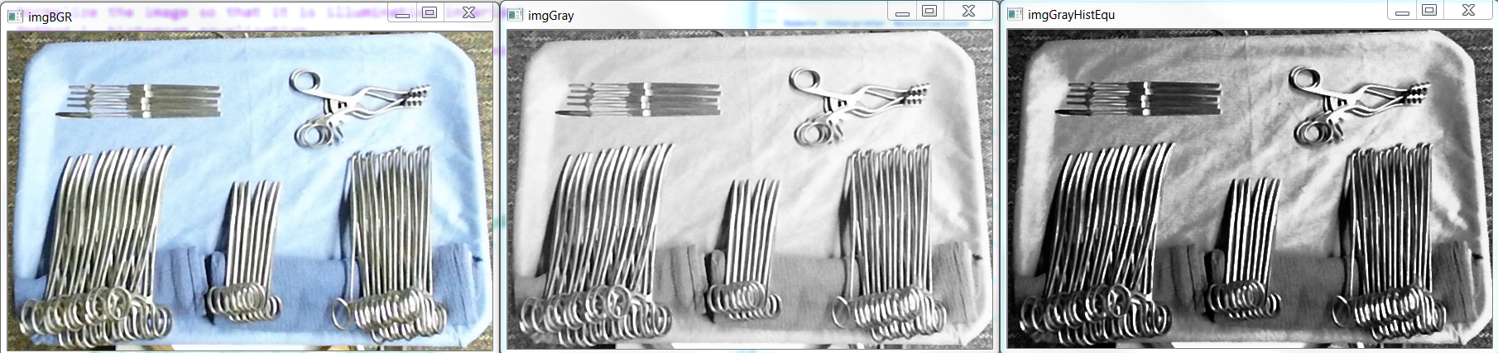

Figure . (left) color image; (middle) grayscale image; (right) grayscale image after histogram equalization

### Harris corner

Below I will show the interesting points found by Harris corner detector, for both foreground and background. Image patches will be extracted from those interesting points.

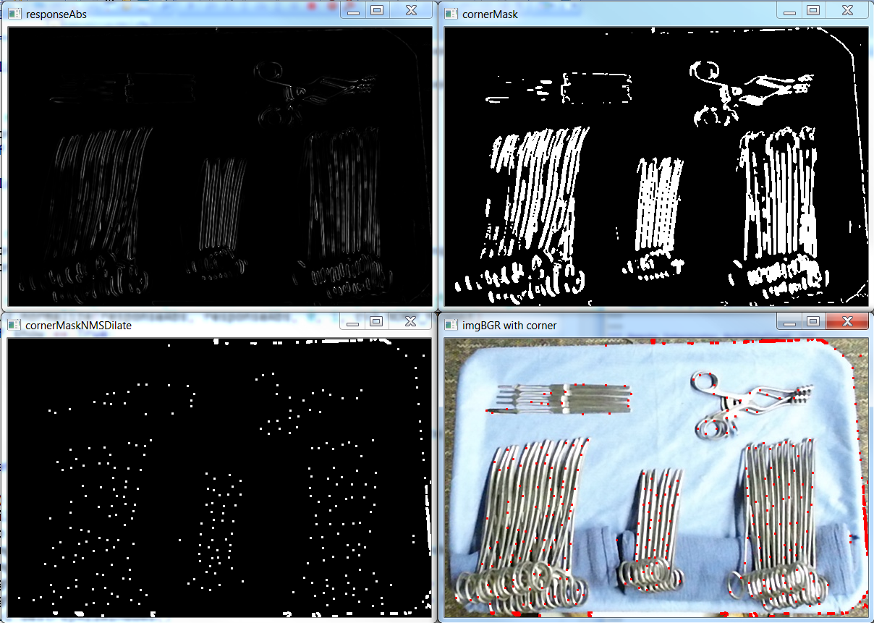

Figure . Interesting points detected for the foreground section. The response for Harris corner detector, rescaled for visualization (upper left). The foreground corner mask after thresholding for the large values of the response matrix (upper right). Apply non-maximum suppression on the corner mask, dots are dilated for better visualization (lower left). The final corner mask overlay on the original color image (lower right).

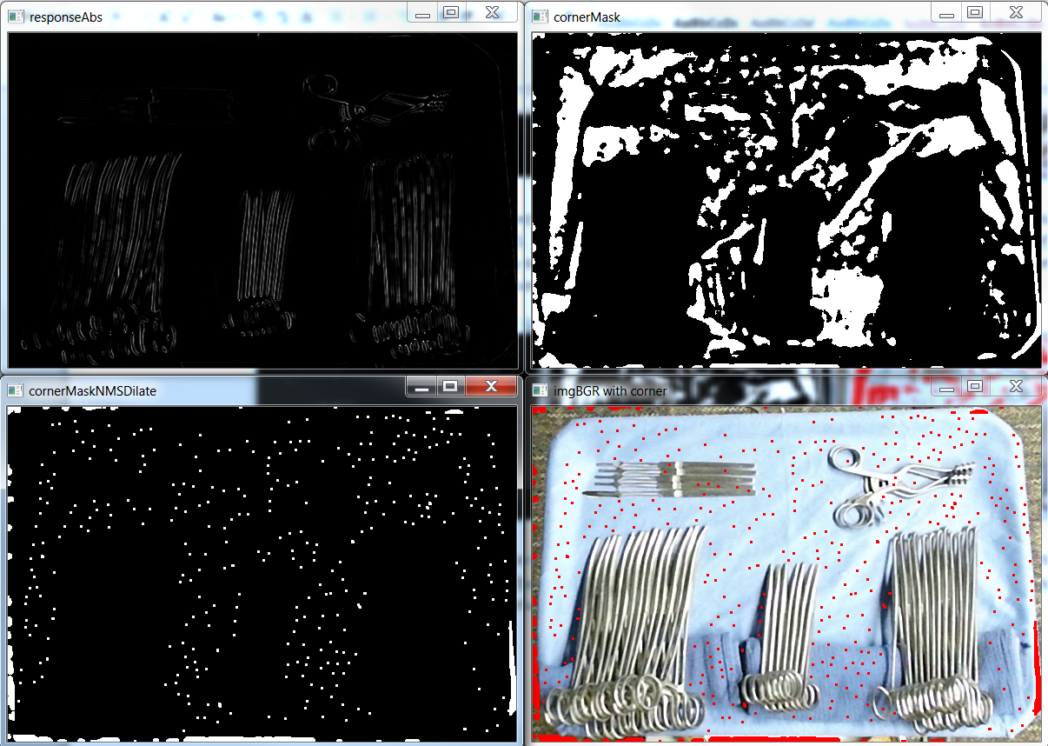

Figure . Interesting points detected for the background section. The response for Harris corner detector, rescaled for visualization (upper left). The background corner mask after thresholding for the small values of the response matrix (upper right). Apply non-minimum suppression on the corner mask, dots are dilated for better visualization (lower left). The final background mask overlay on the original color image (lower right).

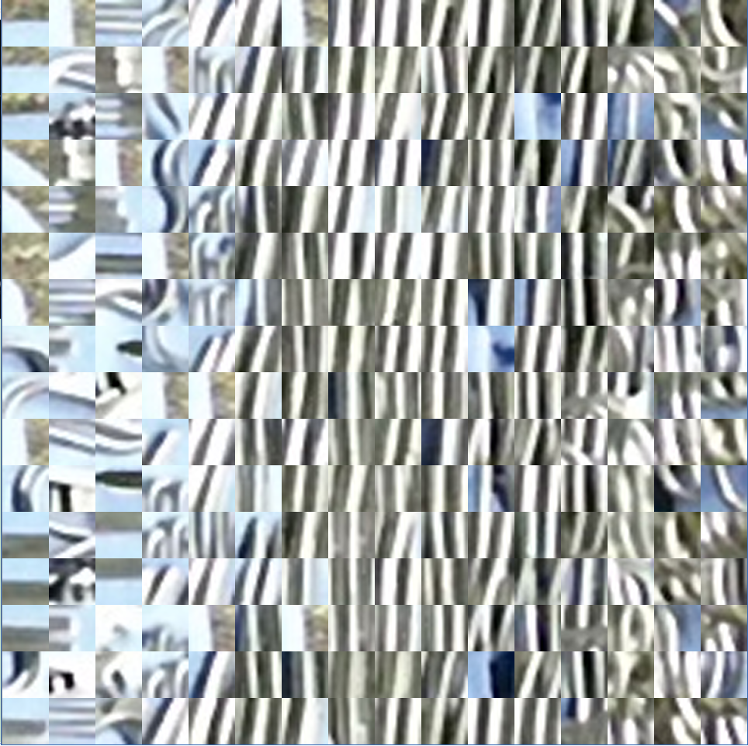

Figure . Extracted patches of size 15 x 15 for the foreground image from one training example (before clustering)



Figure . Extracted patches of size 15 x 15 for the background image from one training example (before clustering)

### Clustering of color patches

It is impossible for us to store all the extracted color patches, since there are just too many of them. We need to run the clustering and then summarize the color patches into codebooks which are representative. To that end, we used the Agglomerative clustering method and cluster the color patches together. The similarity measure between color patches is the normalized grayscale correlation. After clustering, the average image of all the member patches for each cluster will be used as the representative for this cluster, and will be stored as the codebook entry. Some clustering results are shown in Figure 6, where $I_{j}$ represents a codebook entry extracted from one cluster and in total we find $N$ codebook entries. In the $N$ codebook entries, we have $N_{1}$ codebook entries related to hypothesis $H_{1}$ and $N_{0}$ codebook entries related to hypothesis $H_{0}$. The probability of observing a codebook entry given a Hypothesis is estimated using the relative cluster frequency for each codebook entry: $P\left(I_{j} | H_{1}\right)=\frac{\left|I_{j}\right|}{\sum_{i=1}^{N}{|I_{i}|}}$



Figure . Sample cluster of color background for foreground (blue) and background (red). The leftmost column indicates the average image of each cluster members, which are stored as codebook entries.

The effect of different clustering sizes in the Agglomerative clustering was studied. There is a tradeoff between time and efficiency. The more clusters we keep, the longer the algorithm will take to finish the clustering, but as a result we will get a finer and more accurate clustering result. Another issue is that too large a cluster size may lead to overfitting to the training dataset. The metric to evaluate the resultant clustering of Agglomerative is the sum of all the within cluster distances, the smaller the distance is, the better the clustering result is. The result of one such experiment is shown in

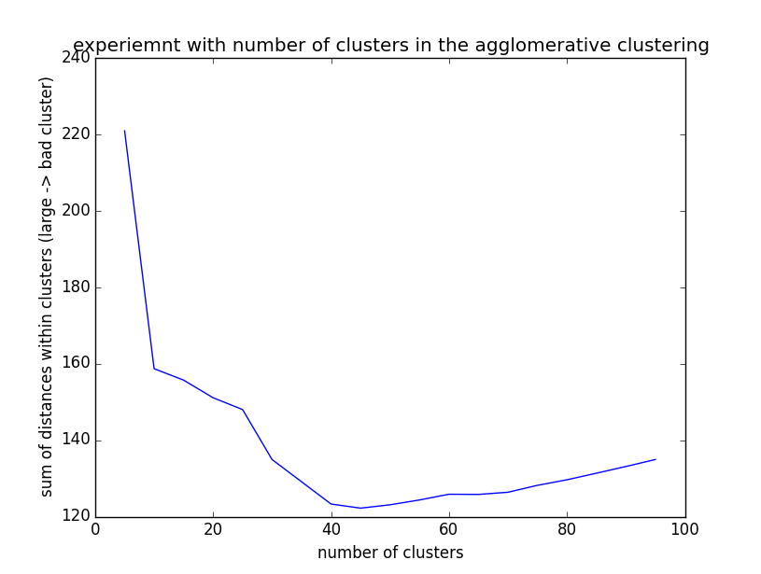

Figure . Experiment with number of clusters in the Agglomerative clustering. From the picture we know that a cluster size of around 40 is the optimal.

## Miscellaneous

### Threshold in different color systems

It is worth the time to study how the foreground and background differ in different color systems. If there is one channel in one of the color systems which can perfectly separate the foreground with the background (in all different lighting situations), that might be a good solution. To that end, we convert the color image from RGB space to other spaces and show the result below:

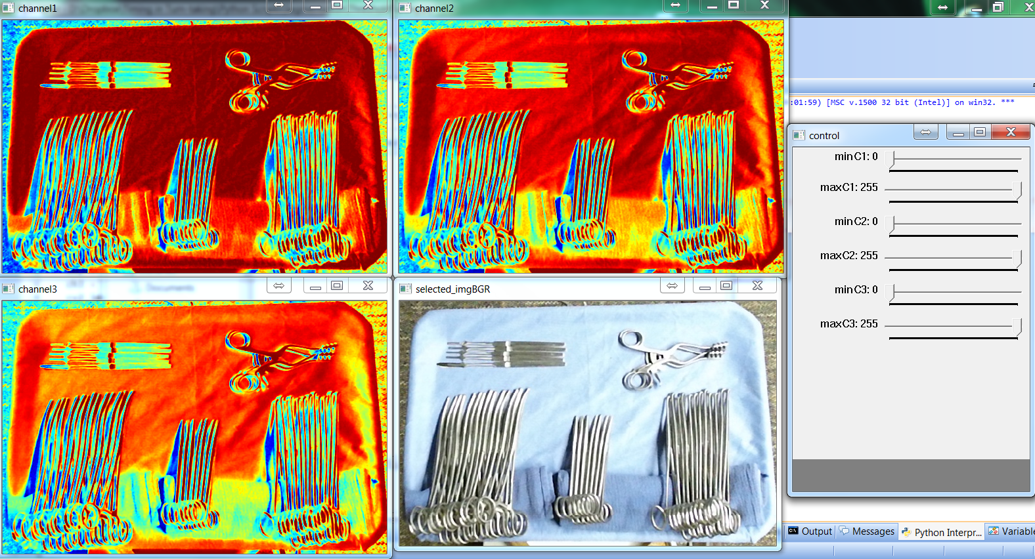

Figure 8. BGR

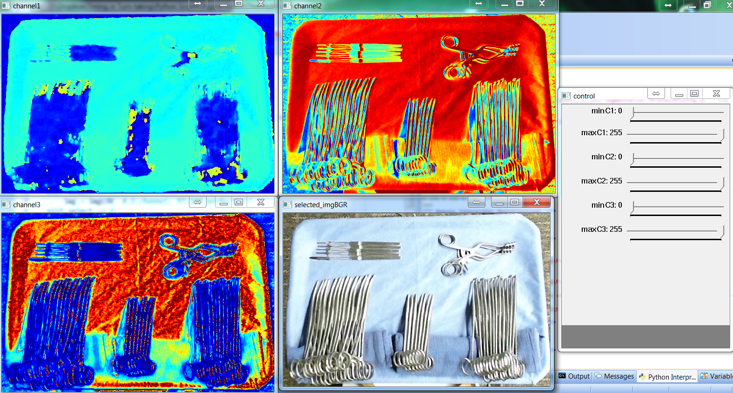

Figure 9. HLS

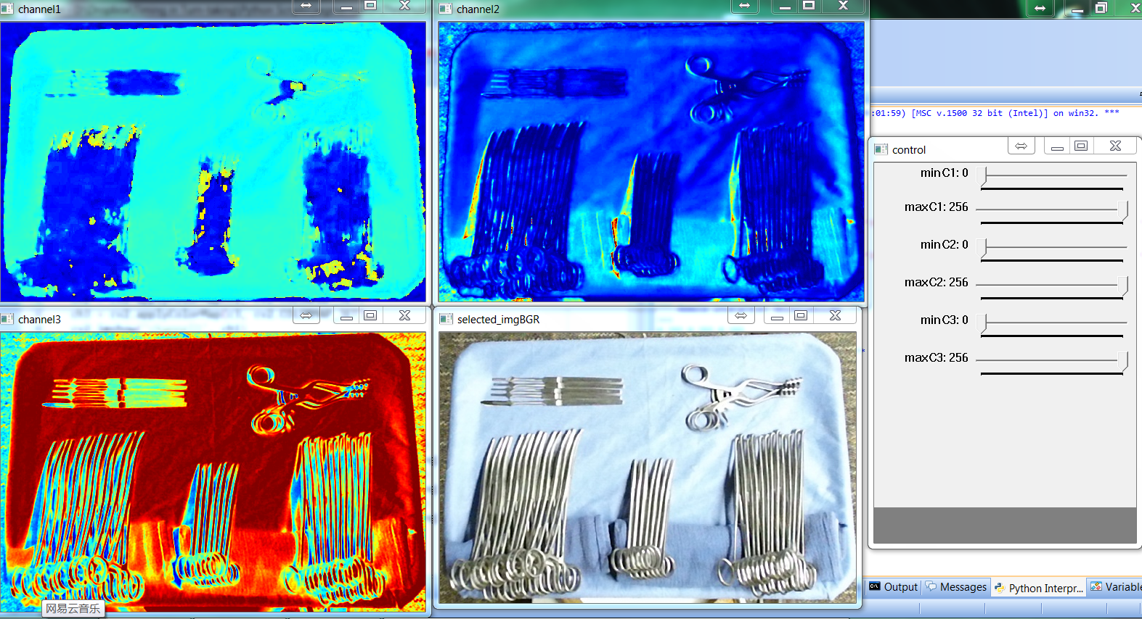

Figure 10. HSV

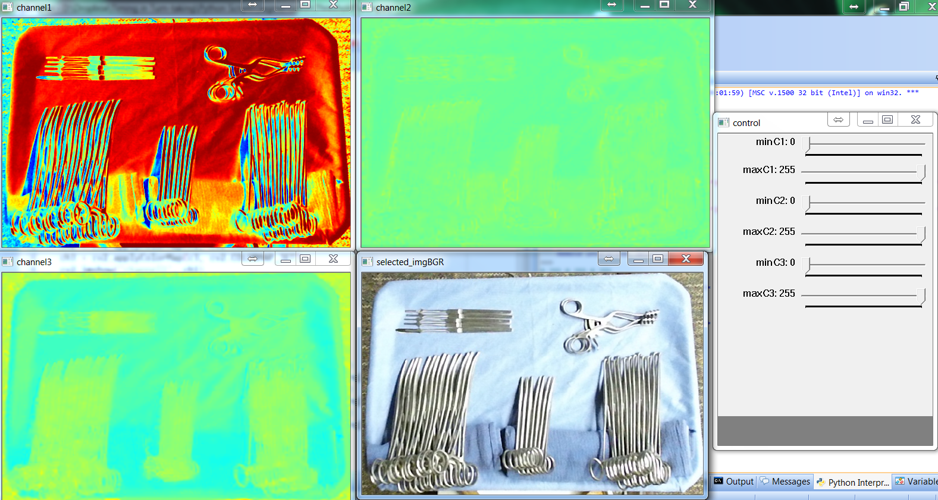

Figure 11. LAB

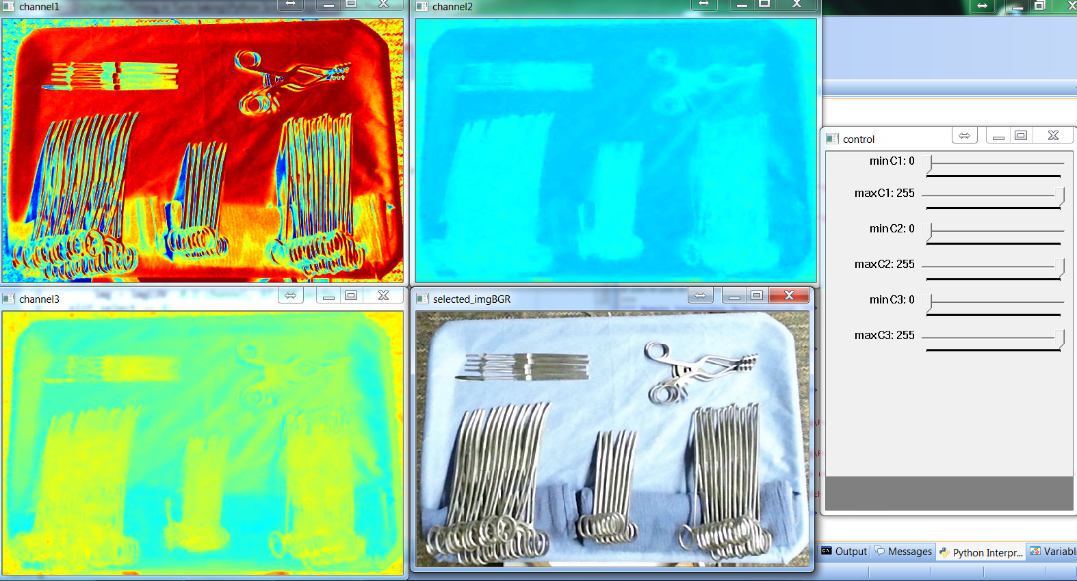

Figure 12. LUV